**Rivona Caves**

The Rivona Caves are situated in the Rivona village of south of [**Goa**](https://www.indianetzone.com/3/goa_state.htm).

Rivona Caves are also recognized as Pandava Caves and they have been assessed to have been built in the 6th or the 7th centuries by Buddhist monks. Buddhism was spreading to all over the country and Goa was no exclusion. In the far deep inside the [**forest**](https://www.indianetzone.com/2/indian_forests.htm) areas, the caves were carved out of rock faces by the monks making them their housing and meditation parts. Though the [**historians**](https://www.indianetzone.com/40/indian_historians.htm) consider the monks to have been the ones to have built these caves and lived here, the locals believe otherwise. They strongly believe that the caves were the dwelling of the **[Pandavas](https://www.indianetzone.com/13/pandava.htm" \o "Pandavas , Mahabharat)** throughout their period in exile.

The main opening to the caves is next to a small stepped well or tank at the bottom of the rock. This is flanked by a 16th century bas-relief of Hanuman, the Hindu monkey God and leads to the cell on the upper level.

1st image :

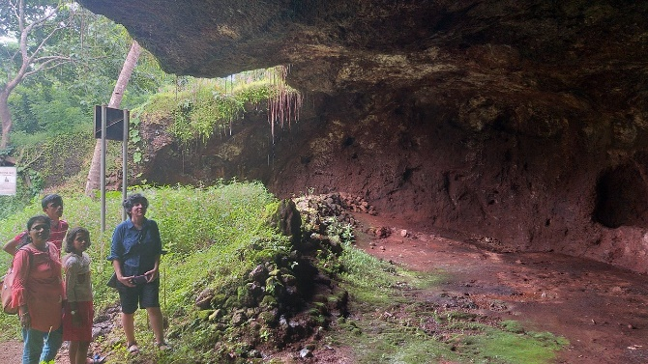

<https://media-cdn.tripadvisor.com/media/photo-m/1280/1a/8d/8e/fd/entrance-to-the-cave.jpg>

2nd image:

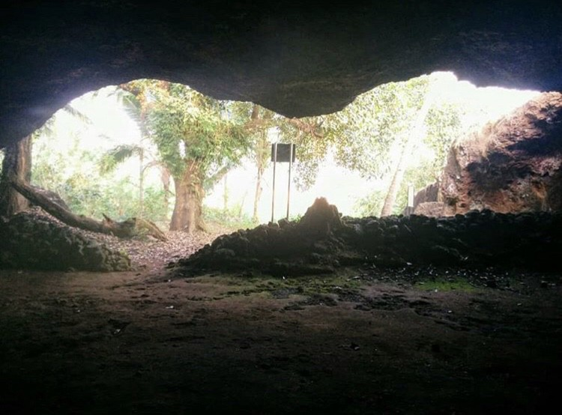

[https://miro.medium.com/max/1500/1*6c7C-gX9qYSnHuJLVZISHw@2x.jpeg](https://miro.medium.com/max/1500/1*6c7C-gX9qYSnHuJLVZISHw@2x.jpeg)